NAME: K Yamini
REG NO: 192572181

Write a Prolog Program for Backward Chaining. Incorporate required queries.
Aim:
To implement Backward Chaining in Prolog using facts and rules to prove a given goal.
Algorithm:
- Start the program.
- Define the initial facts.
- Define the rules.
- Select the required goal.
- Check whether the goal is directly available as a fact.
- If not, find a rule whose conclusion matches the goal.
- Check whether the condition of that rule is true.
- Continue checking backwards until a known fact is reached.
- If all required conditions are satisfied, prove the goal.
- Display the result.
- Stop the program.
Prolog program:
% EXPERIMENT 30
% Backward Chaining

% Facts
fact(sunny).
fact(warm).

% Rules
rule(sunny, outdoor).
rule(warm, comfortable).
rule(outdoor, happy).
rule(comfortable, happy).

% Backward chaining
prove(Fact) :-
fact(Fact).

prove(Fact) :-
rule(Condition, Fact),
prove(Condition).

% Main program
backward_chaining :-
write('Given Facts:'), nl,
write('- sunny'), nl,
write('- warm'), nl, nl,

write('Goal: happy'), nl,
write('Checking backward...'), nl,

prove(happy),

write('Goal happy is proved.'), nl,
!.
Input:
In GNU Prolog, enter:
?- backward_chaining.
You can also test:
?- prove(happy).
Output :
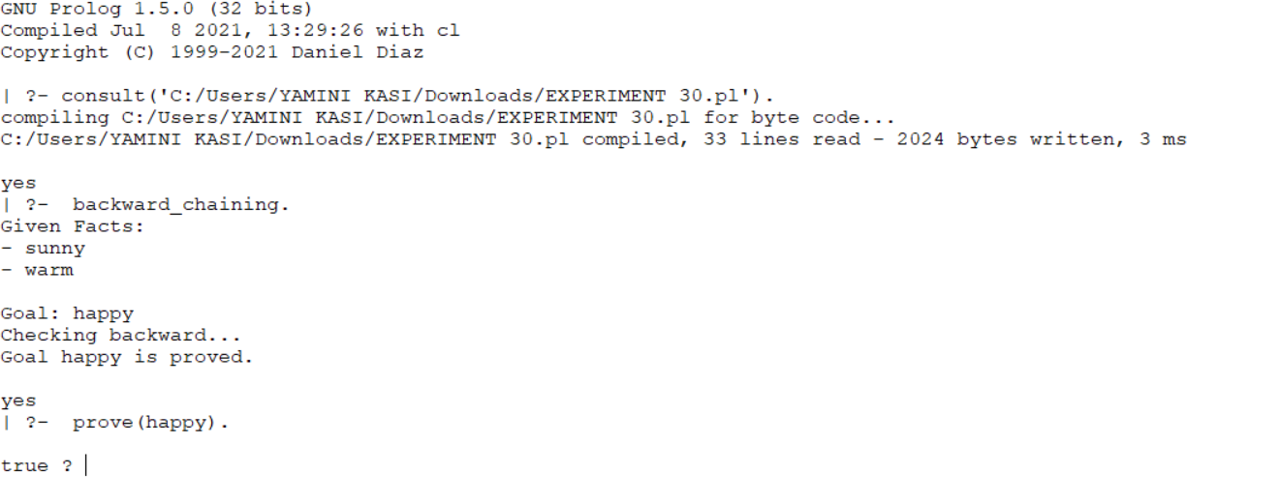
Result:
Thus, the Backward Chaining problem was successfully implemented in Prolog, and the given goal was proved using facts and rules.

